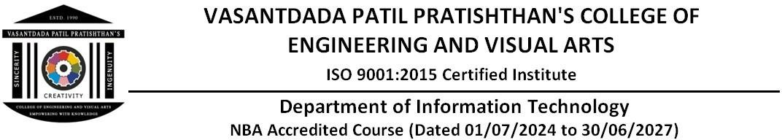

# EXPERIMENT - 11

**Aim:** To understand AWS Lambda, its workflow, various functions and create yourfirst Lambda functions using Python / Java / Node js.

# Theory:

**AWS Lambda:**

AWS Lambda is **a serverless compute service provided by Amazon Web Services (AWS).** It allows developers to run code in response to events without provisioning or managing servers. Thisevent-driven, serverless Function as a Service (FaaS) enables rapid and cost-effective modern applications development.

# Some examples of various AWS Lambda functions

1. **Image Resizing**: A Lambda function can be triggered by an Amazon S3 object upload and resize images to different dimensions, making them suitable for different use cases (e.g.,thumbnails, banners).
2. **Real-time Data Processing**: Lambda functions can be used to process real-time data fromIoT devices, such as sensor readings, and trigger actions like sending notifications or updating databases.
3. **API Gateway Integration**: Lambda functions can be used as the backend for API Gateway, handling API requests and responses, and integrating with other AWS services like DynamoDBor S3.
4. **Chatbot or Virtual Assistant**: A Lambda function can be triggered by voice or text inputand respond with relevant information or actions, integrating with services like Amazon Lexor Amazon Comprehend.
5. **Email Processing**: Lambda functions can be used to process and analyze email attachments,such as extracting metadata or sending notifications to team members.
6. **Log Processing**: Lambda functions can be triggered by Amazon CloudWatch Logs and processlog data, such as aggregating metrics, detecting anomalies, or sending alerts.
7. **Webhook Processing**: Lambda functions can be used to process webhooks from third-partyservices, such as payment gateways or social media platforms, and trigger actions in yourapplication.

STEPS:

1. Sign in to the AWS Management Console, and search for Aws lambda service.

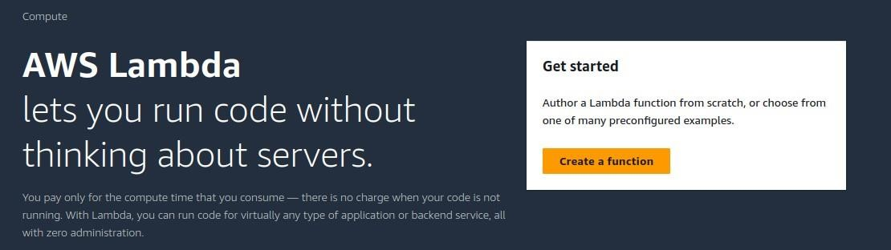

1. Click create a function

Enter the details as given below. → Create

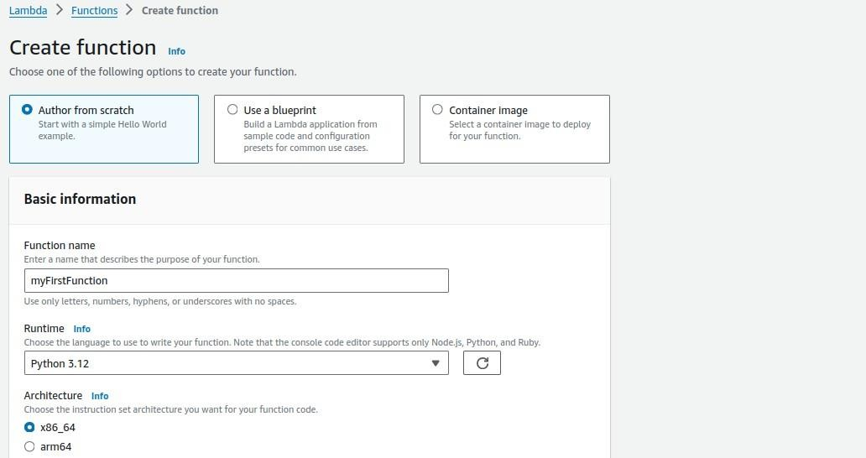

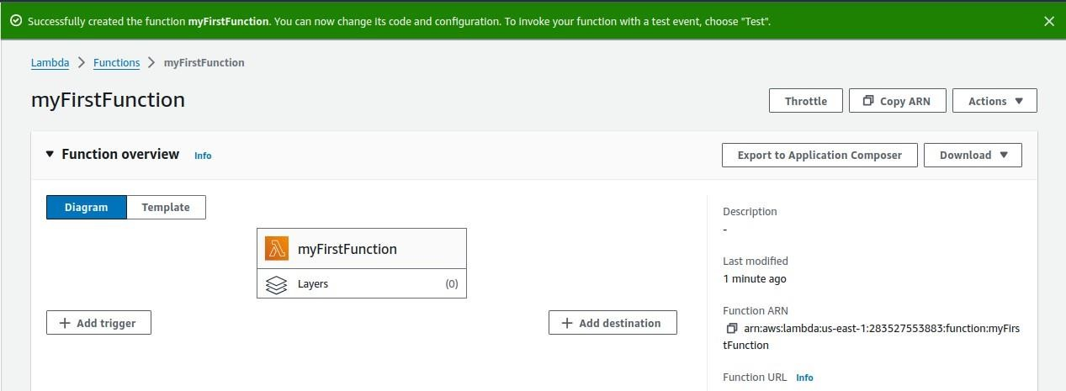

Scroll down to code section,

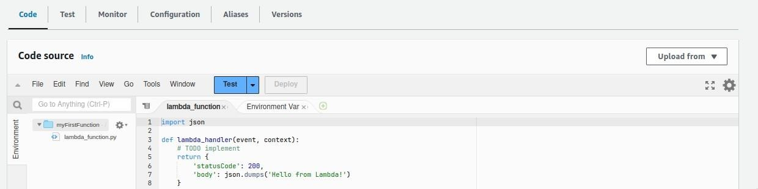

Now change the default code with this:

import json

def lambda_handler(event, context):

print("Received event: " + json.dumps(event, indent=2)) message = 'Hello from Lambda!'

return {

'statusCode': 200,

'body': json.dumps(message)

}

Then, click on deploy, After it is deployed click on “Test”

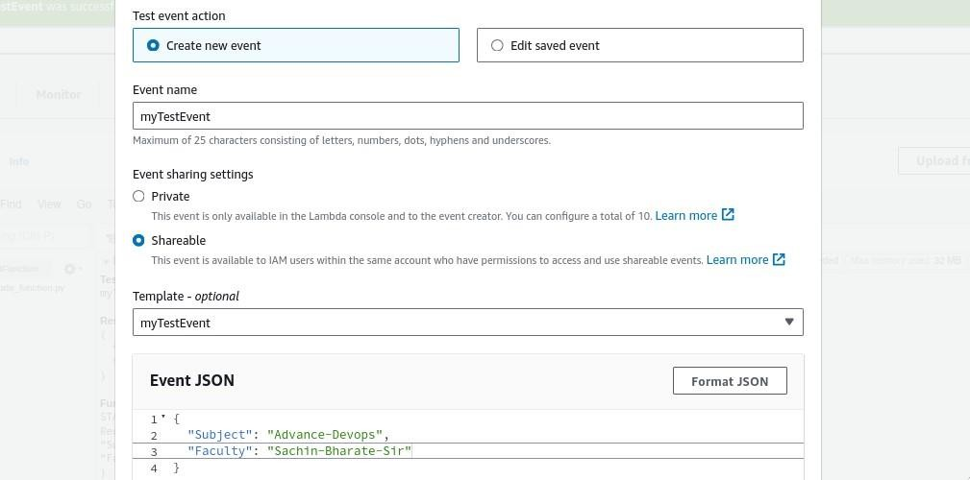

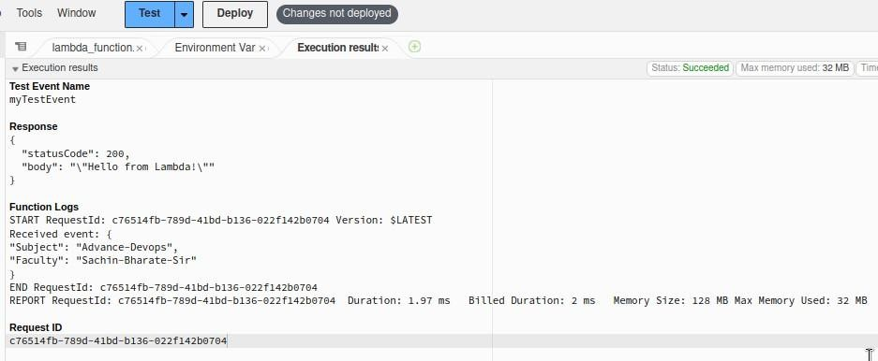

**Conclusion:** Thus, we have successfully understood AWS Lambda, its workflow, various functions and created our first Lambda functions using Python / Java / Nodejs.